

MECHATRONICS SYSTEM INTEGRATION (MCTA 3203)
SEMESTER 2 2025/2026

WEEK 5: CONTROLLING A 12V DC LINEAR ACTUATOR USING L298P MOTOR DRIVER AND RELAY

SECTION 1
GROUP 7

INSTRUCTOR: DR WAHJU SEDIONO & ASSOC. PROF. EUR. ING. IR. TS. GS. INV.
DR ZULKIFLI BIN ZAINAL ABIDIN

NO | NAME | MATRIC NO
1 | MUHAMMAD FARISH BIN AB LATIF | 2329227
2 | MUHAMMAD DANISH BIN MOHD HANIFAH | 2311377
3 | MUHAMMAD FARQI SARHIDI BIN ABDUL HAFAZ | 2316461

ABSTRACT

This experiment demonstrates the design and implementation of a control system for a 12V DC linear actuator using an L298P motor driver combined with a dual-relay setup. The main objective was to achieve bi-directional motion control along with speed regulation, while incorporating safety feedback mechanisms. The study was conducted in two stages: the first involved establishing the basic H-bridge logic to control polarity and applying Pulse Width Modulation (PWM) for adjustable speed; the second focused on integrating a limit switch sensor to automate the stopping process and provide visual indication through an LED.
The results showed that the H-bridge configuration successfully reversed motor polarity, enabling both extension and retraction of the actuator, while the PWM signal effectively controlled its speed. In addition, the inclusion of sensor feedback enhanced precision and safety by stopping the actuator upon physical contact. Overall, this experiment confirms the effectiveness of combining solid-state motor drivers with electromechanical relays for handling high-current linear motion applications in automated systems.

TABLE OF CONTENTS
INTRODUCTION
TASK 1
1.0 MATERIAL AND EQUIPMENT
1.1 EXPERIMENTAL SETUP
1.2 METHODOLOGY
a. Circuit Assembly
b. Circuit Logic
1.3 DATA COLLECTION
1.4 DATA ANALYSIS
1.5 RESULT
1.6 DISCUSSION
TASK 2
2.0 MATERIALS AND EQUIPMENT
2.1 EXPERIMENTAL SETUP
2.2 METHODOLOGY
a. Circuit Assembly
b. Programming and Uploading
c. Programming Logic
d. Programming Coding
2.3 DATA COLLECTION
2.4 DATA ANALYSIS
2.5 RESULT
2.6 DISCUSSION
CONCLUSION
RECOMMENDATION
REFERENCES
ACKNOWLEDGEMENT
STUDENTS DECLARATION
Certificate of Originality and Authenticity

INTRODUCTION

Linear actuators are essential components in modern robotics and industrial automation, as they provide accurate linear motion by converting the rotational energy of a DC motor into translational movement. Controlling these actuators requires a reliable interface capable of handling higher current and voltage levels typically 12V or more—which cannot be supplied directly by standard microcontrollers. The L298P motor driver functions as a dedicated H-bridge integrated circuit, enabling high-power switching and directional control. By applying the principles of electromagnetic induction and mechanical leverage, such systems support automated operations ranging from basic gate mechanisms to advanced robotic limb movements.

In the first phase of the experiment, the emphasis was placed on understanding directional control and speed regulation of the actuator. The H-bridge circuit configuration was analysed to observe how diagonal switching patterns change the polarity across the motor terminals, allowing transitions between clockwise and counterclockwise rotation, corresponding to extension and retraction. To achieve more refined control beyond simple on/off operation, Pulse Width Modulation (PWM) was implemented. By rapidly switching the enable pin of the L298P driver, the average voltage supplied to the actuator could be adjusted, resulting in smoother acceleration and deceleration, which helps minimize mechanical wear on internal components.

The second phase increased the system’s complexity by introducing a closed-loop feedback mechanism through sensor integration. While manual control is sufficient for simple tasks, practical industrial systems require environmental awareness to prevent damage or malfunction. This was accomplished by incorporating a limit switch along with a dual-relay configuration. The control logic was programmed to continuously monitor the sensor state; once the limit switch was activated, the microcontroller would interrupt the actuator’s operation, trigger an LED indicator, and implement a brief delay. This phase highlights the significance of integrating hardware and software, demonstrating how mechanical inputs can override control signals to ensure safe, consistent, and automated operation cycles.

Experiment 1 : Control DC Linear Actuator using L298P motor driver Task 1

- MATERIALS AND EQUIPMENTS

- Cytron CT Uno
- Four Push Button
- DC Motor
- Battery 9V
- Breadboard
- Jumper Wires

  - EXPERIMENTAL SETUP

-The L298P motor driver shield is mounted directly onto the Cytron CT Arduino UNO.
-The linear actuator terminals are connected to Motor A output of the motor driver.
-The external 12V power supply is connected to:
● VMS (Motor Supply) → Positive terminal
● GND → Negative terminal
-Control pins:
● D10 (PWM) → Speed control
● D12 (Digital) → Direction control
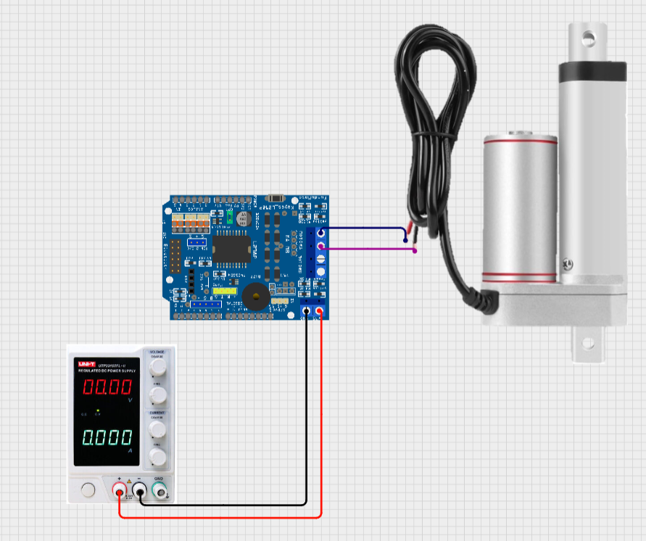
Figure 3.1 Circuit connection

1.2 METHODOLOGY

- Circuit assembly
• Connect the component as shown in Fig.1
- Circuit logic

• The motor spins to the right direction when the top left button and the bottom right button pushed simultaneously.
• The motor spins to the left direction when the top right button and the bottom left button pushed simultaneously.

1.3 DATA COLLECTION

Push Button Condition Top Left + Bottom Right Motor Rotation Top Right + Bottom Left Clockwise Anti-clockwise Otherwise Stopped

1.4 DATA ANALYSIS

The H-bridge was successfully converts a single polarity DC source into a bidirectional output through coordinated switching. When the top left button and the bottom right button are pressed, the polarity of the motor remain in one direction, resulting in clockwise rotation. When the top right button and the bottom left button are pressed, the polarity is reversed, causing the motor to rotate in anticlockwise direction.

  - RESULT

The experimental setup successfully demonstrated the fundamental principles of DC motor polarity reversal. By activating diagonal pairs of switches, the actuator able to perform two distinct mechanical action which is rotates to the right and to the left. When all buttons were in the OFF state, the actuator remained stationary.

  - DISCUSSION

The experiment validates that a four-switch H-bridge is a reliable method for controlling a linear actuator. The assembly correctly manages current flow to allow for bidirectional motion, provided that the diagonal switching logic is strictly maintained to avoid system shorts. It is suggested to transform from a Tinkercad simulation to a physical circuit to ensure the system is efficient and achievable. After the basic circuit is successfully operated as required, replaced the push button with a dedicated H-bridge IC such as L298P and use a microcontroller to send a Pulse Width Modulation (PWM) signal to enable the actuator to move at varying speed.

Experiment 2: Control DC Linear Actuator using 2 Way Channel Relay Task 2

2.0 Material And Equipment

● Cytron CT Arduino Uno
● 2 Way Channel Relay
● DC 12V Linear Actuator
● Variable Power Supply or 12V Power Supply
● Jumper Wires
● Breadboard

2.1 Experimental Setup

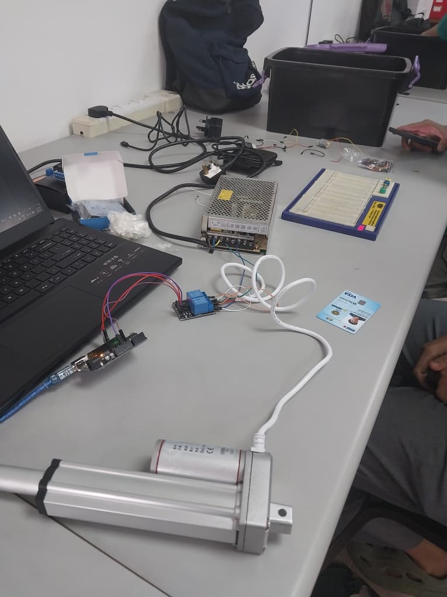

1. Arduino to Relay Module Connections
● IN1 → Arduino Pin 7
● IN2 → Arduino Pin 8
● VCC → 5V (Arduino) ● GND → GND (Arduino)

2. Power Supply Connections
● Positive terminal (+12V) → Connected to NO (Normally Open)
● Negative terminal (GND) → Connected to NC (Normally Closed)

3. Linear Actuator Connections
● The two terminals of the linear actuator are connected to the COM (Common) terminals of the relay module

2.2 METHODOLOGY

- Circuit assembly

• The positive of variable power supply is being connected to both NC pins of 2 way channel relay and the negative side is being connected to both NO pins of two way channel pins.
• The 12VDC linear actuator is being connected to COM pin on the relay.
• The VCC of 2 way channel relay is being connected to pin 5V and GND is connected to the GND of 2-way channel relay.
• The pin 8 of CYTRON-CT to pin IN2 and the pin 7 is being connected to pin IN1 of 2 way channel relay.

- Programming and uploading

• The Arduino IDE software was opened on the computer.
• The correct board type (Arduino Uno) and communication port (COM port 9) were selected in the Tools menu.
• The coding was uploaded and compiled with no syntax errors

c. Programming logic
• When the actuator being retract the LED is turn off and when the actuator stops the LED is turn on.
• Both conditions applied when they hit the limit switch by using while =(digitalRead(limitswitch)==HIGH)
• When the actuator being extend the relay 1 is turn on and relay 2 is turn off by using digitalwrite(relay1,HIGH) digitalwrite(relay2,LOW)
• When the actuator being extract, the relay 1 is turn off and relay 2 is being turn on digitalwrite(relay1,LOW) digitalwrite(relay2,HIGH)
• When the actuator being stopped both relay 1 and relay 2 is being turn off.

d.Programming code

const int relay1 = 7; // Extend
const int relay2 = 8; // Retract
const int switchPin = 2; // Micro switch
const int ledPin = 13; // LED

void setup()
{ pinMode(relay1, OUTPUT);
pinMode(relay2, OUTPUT);
pinMode(switchPin, INPUT_PULLUP);
pinMode(ledPin, OUTPUT);

stopActuator();
digitalWrite(ledPin, LOW);

Serial.begin(9600);

} void loop()

{ Serial.println("Extending actuator...");
extendActuator();

// Wait until the micro switch is pressed
while (digitalRead(switchPin) == HIGH)
{
delay(10);
}
Serial.println("Target reached");
stopActuator();

digitalWrite(ledPin, HIGH); // LED ON when target reached
delay(1000);

Serial.println("Retracting actuator...");
retractActuator();
delay(5000); // Adjust this based on your actuator speed
stopActuator();
digitalWrite(ledPin, LOW); // LED OFF after retract

Serial.println("Cycle complete");
delay(3000);

}
void extendActuator()

{ digitalWrite(relay1, HIGH);
digitalWrite(relay2, LOW);
} void retractActuator()

{ digitalWrite(relay1, LOW);
digitalWrite(relay2, HIGH);

} void stopActuator()

{ digitalWrite(relay1, LOW);

digitalWrite(relay2, LOW);
}

2.3 DATA COLLECTION

Limit Switch | Linear Actuator | Led
Limit switch being hit | Linear actuator going up | Turn on
Limit switch not being hit | Linear actuator going down | Turn off

2.4 DATA ANALYSIS

The system used two relays (relay 1 and relay 2) to control the direction of the DC Motor inside the linear actuator. Using the extendactuator() function, we can see the actuator will moving up when relay 1 (Pin 7) HIGH and relay 2 (Pin 8) LOW. Using the retractActuator() the relay 1 (Pin 7) LOW and relay 2 (HIGH), it will move the actuator going down .When the limit switch is hit, the code will goes to the while loop and will call stopActuator().The LED turns ON, and the system pauses for 5 seconds because delay (5000). When the LED turns off the loop () will start over and extending the actuator again.

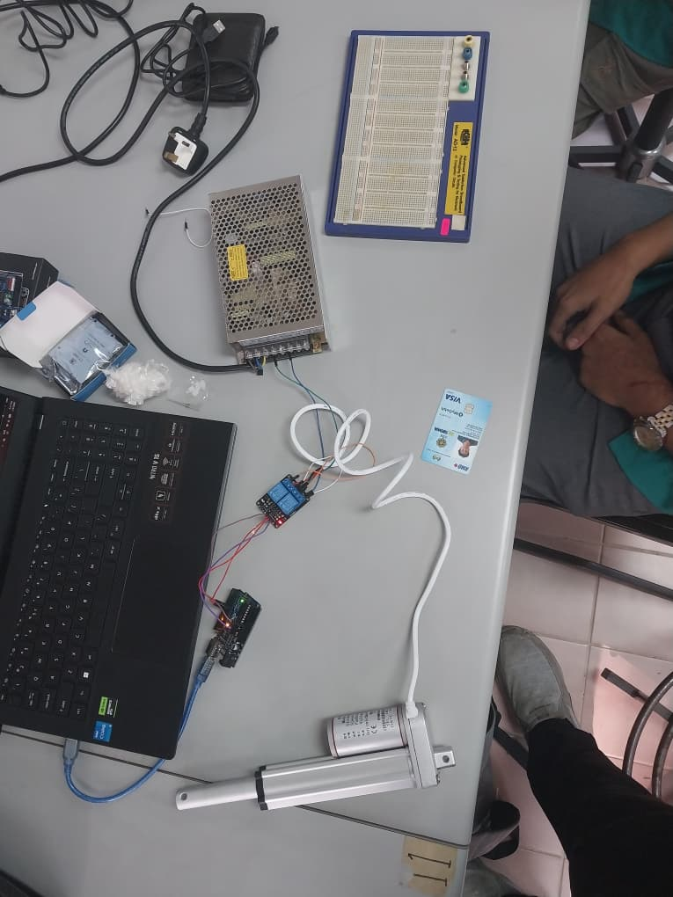

2.5 RESULT

The experiment successfully demonstrates the implementation of an automated control system for a linear actuator. The actuator’s motion is effectively regulated using a 2-channel relay module, which enables controlled extension and retraction by switching the direction of current flow. The incorporation of a limit switch ensures accurate position detection and enhances system safety by automatically stopping the actuator once the predefined limit is reached. Additionally, an LED indicator provides a clear and immediate visual signal to confirm when the actuator has reached its target position. Overall, the system exhibits reliable performance, showcasing efficient integration between control, sensing, and actuation components. This setup also highlights the practical application of basic automation principles in real-world electromechanical systems.

2.6 DISCUSSION

The concept of an H-bridge is implemented within the control logic using two relays. This approach allows the DC motor to rotate in both directions by reversing the polarity of the supply voltage across the motor terminals. For instance, during the extension process, when Relay 1 is set to HIGH and Relay 2 is set to LOW, current flows in one direction, causing the actuator to extend. Conversely, switching the relay states reverses the current flow, resulting in retraction.
Relays are chosen instead of transistors because they provide electrical isolation between the high-voltage motor circuit and the Arduino’s low-voltage control circuitry, thereby protecting sensitive components. Additionally, relays are capable of handling higher current loads without significant heat generation, making them suitable for applications involving repetitive motion such as extension and retraction cycles.
Furthermore, this configuration demonstrates a simple yet effective method of implementing bidirectional motor control without requiring complex driver circuits. It highlights the importance of combining electrical safety, control logic, and practical component selection in designing reliable electromechanical systems.

CONCLUSION

The first task successfully demonstrated that the fundamental principles of an H-bridge are crucial for controlling the bi-directional motion of a linear actuator. By transitioning from a manual push-button configuration to the L298P motor driver, the system achieved improved capability in handling higher current loads with greater stability and reliability. In addition, the implementation of Pulse Width Modulation (PWM) provided an efficient method for speed control. By varying the duty cycle of the PWM signal, the actuator’s extension and retraction speeds could be precisely adjusted to meet specific operational requirements. This phase also emphasized the importance of maintaining proper diagonal switching logic within the H-bridge configuration to prevent short circuits (shoot-through conditions), thereby ensuring safe operation and prolonging the lifespan of the motor driver.
In the second task, the integration of relays and a limit switch effectively transformed the system from an open-loop configuration into a more responsive and automated control system. The use of two relays enabled reliable polarity reversal, forming a simplified H-bridge mechanism suitable for higher power applications. At the same time, the limit switch acted as a feedback component, allowing the actuator to stop automatically once it reached a predefined position, improving both accuracy and safety. The addition of an LED indicator provided clear visual feedback on system status, while a programmed delay introduced a controlled pause before the next operation cycle, reducing mechanical stress and enhancing overall system stability.
Overall, this experiment demonstrates that combining high-power switching devices, control logic, and sensor feedback results in a robust, safe, and repeatable motion control system. It highlights the practical application of electromechanical integration principles commonly used in industrial automation and robotics systems.

RECCOMENDATION

It is recommended to use the L298P motor driver for applications that require precise control of speed and direction, as it supports advanced techniques such as Pulse Width Modulation (PWM) for smooth and adjustable motion. In contrast, relay modules are more suitable for simpler ON/OFF control scenarios where high precision is not critical but robust high-current switching is needed.
Incorporating sensors such as limit switches significantly enhances system automation by enabling position-based stopping, which helps prevent mechanical damage and improves operational safety. Additionally, integrating protective components—such as flyback diodes, fuses, and proper grounding—can further safeguard both the control circuit and power components from electrical faults and voltage spikes.
For future improvements, the system could be upgraded with closed-loop control using feedback devices like encoders or position sensors to achieve higher accuracy and consistency. Moreover, implementing wireless monitoring or IoT-based control would allow real-time tracking and remote operation, increasing the system’s flexibility and suitability for modern smart automation applications.

REFERENCESS

STMicroelectronics. (2016). L298 dual full-bridge driver datasheet. https://www.st.com/resource/en/datasheet/l298.pdf

Arduino. (2023). PWM control using Arduino. https://www.arduino.cc

Rashid, M. H. (2014). Power electronics: Circuits, devices, and applications (4th ed.). Pearson Education.

Texas Instruments. (2020). Understanding H-bridge motor drivers. https://www.ti.com

Mohan, N., Undeland, T. M., & Robbins, W. P. (2003). Power electronics: Converters, applications, and design (3rd ed.). John Wiley & Sons.

ACKNOWLEDGEMENT

We would like to sincerely thank the instructors, Assoc. Prof. Eur. Ing. Ir. Ts. Gs. Inv. Dr. Zulkifli Bin Zainal Abidin and the lab technicians, for all of their help, encouragement and support during this project. Their knowledge and perceptions have greatly influenced the course of this work. Additionally, we would like to express our gratitude to our peers for their support and cooperation, both of which were crucial to the accomplishment of this project.

STUDENTS DECLARATION

We hereby declare that, except for the places where it is acknowledged, all of the work presented in this report is entirely ours. We certify that, in completing this project, we have complied with the standards of academic integrity and have not engaged in any plagiarism or unethical behaviour. Every information and support source used in this work has been appropriately referenced and acknowledged.

Certificate of Originality and Authenticity

This is to certify that we are responsible for the work submitted in this report, that the original work is our own except as specified in the references and acknowledgement, and that the original work contained herein has not been done by unspecified sources or persons. We hereby certify that this report has not been done by only one individual, and all of us have contributed to the report. The length of contribution to the reports by each individual is noted within this certificate. We also hereby certify that we have read and understand the content of the total report and no further improvement on the reports is needed from any of the individual’s contributor to the report. We therefore agreed unanimously that this report shall be submitted for marking, and this final report has been verified by us.

Signature: Danish
Name: MUHAMMAD DANISH BIN MOHD HANIFAH
Matric Number: 2311377

Signature: Farish
Name: MUHAMMAD FARISH BIN AB LATIF
Matric Number: 2329227

Signature: Farqi
Name: MUHAMMAD FARQI SARHIDI BIN ABDUL HAFAZ
Matric Number: 2316461

